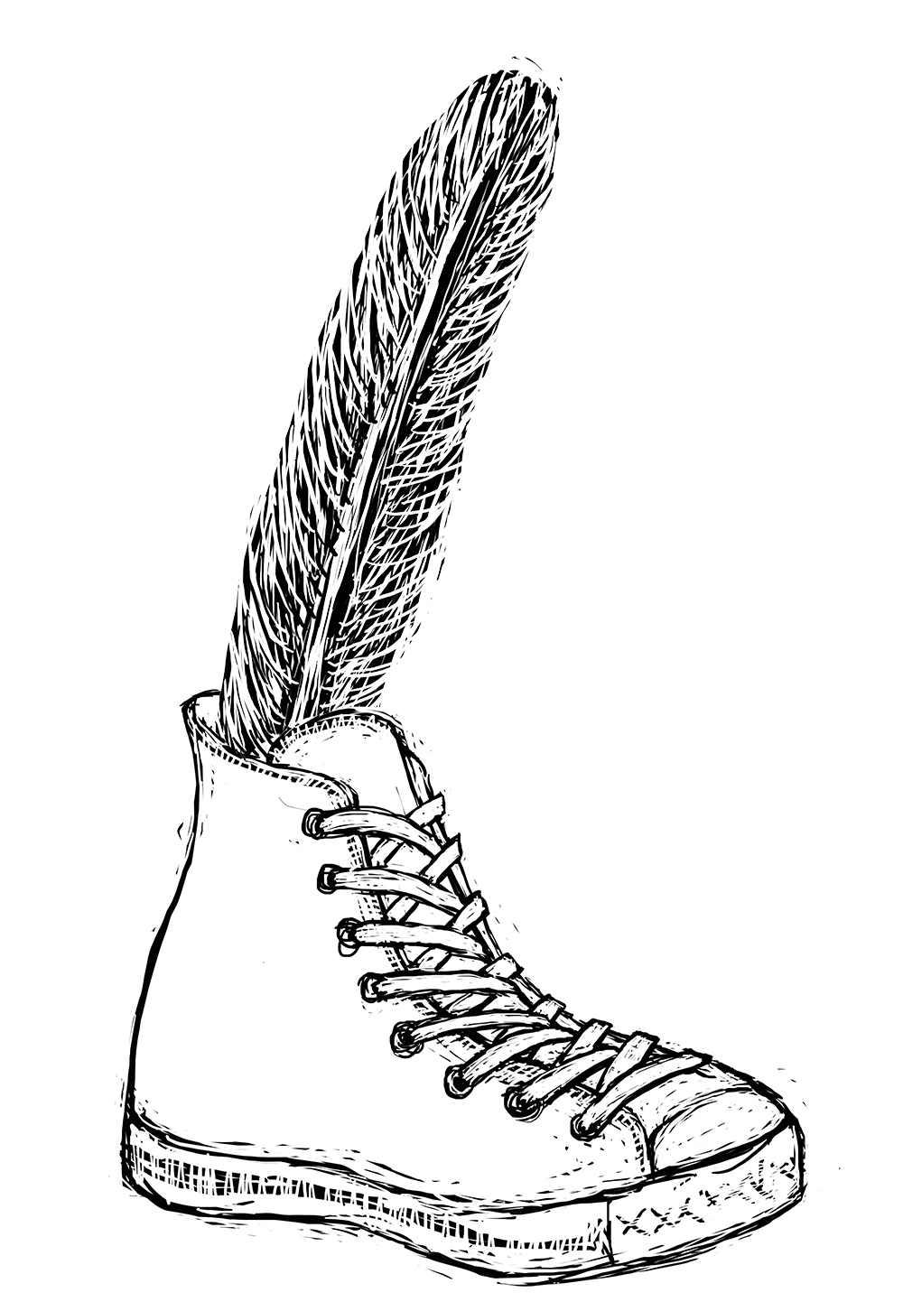
Blue’s River
Teaching Activities for:
Social Studies, Science, ELA, STEM, and Art

Although the activities listed here were written with 3rd through 6th graders in mind, many are appropriate for all ages.

General Activities
- Think about an improvement you would like to see in your neighborhood, school, community or state. What is the problem? How did it become a problem? Has this problem been solved in other communities? If so, how did they solve it? What might be some other solutions? What can you do to help solve this problem? What can adults do? What can community leaders do? How might you communicate your ideas to other people?
- What changes can you, your family, and your school make in how you take care of water resources?
- What is the name of your watershed?
- What is the name of the lake or river that is nearest to your house? If it is a lake, is it human-made? How healthy is this body of water? Can people fish? Can people eat the fish? Can people swim in this lake or river? Has this lake or river’s name changed over time? Write a story about this lake or river.
- Keep a list of vocabulary words that are new to you as you read this book. Which words do you think should be added to the “Water-Related Vocabulary” section in the back?

Ch. 1
- Make a list of careers/jobs that sound interesting to you. Pick one or two and find out what kind of training or education is needed for this job.
- Do you like to speak in front of groups? Why or why not? Why might it be a useful skill to have?
Ch. 2
- Find out where Great Blue Herons live.
- Draw a picture of a Great Blue Heron.
Ch. 3
- What do you like to do after school? Describe a typical afternoon or evening.
- Describe a favorite place of yours. (Your backyard, the beach, a cozy corner in your house, etc.)
Ch. 4
- Research the history of your town: When was it settled? Who settled it? Did any Native American tribes live there first? Why did people choose to live in this location? Did any industries develop over time? Did slavery exist there? If so, what kind of work did enslaved people do? Did people farm in your town? How have farming and other industries changed? Do farms and industries exist in your town today?
Ch. 5
- Describe some of your favorite places in your town.
- When did your state become a state?
- Old Blue tells Andie, “The wonderful thing about humans is that you seem to learn from your mistakes.” List some mistakes humans have learned from.
Ch. 6
- Explorers from the Netherlands, Sweden, Denmark, and England settled in Delaware. Why did they leave their homes, and why did they choose Delaware?
- Did pirates affect your town? If so how?
- Draw pictures that show how fashions have changed over time.
- Why did many men wear white wigs during the colonial era?
- If you live in Dover, draw a map of The Green.
- Draw a map of your town or neighborhood.
Ch. 7
- Draw a picture of everyone you live with and write something about each of those people.
Ch. 8
- What is your favorite bird? Where does this bird live? Draw a picture of a male and female of this species. What are some reasons for why the feathers on males are more colorful than the feathers on females? Describe the lifecycle of these birds. What kind of food do they eat? How many eggs, on average, does a female lay? What do their nests look like? What is the life expectancy of this species? Who are some enemies of this species? What else is interesting about this bird?
- Are there any birds that are endangered or that have gone extinct in your area? If so, what might be some causes? If they are endangered, are there any solutions for bringing them back?
Ch. 9
- Have you ever gone fishing? Do you like to eat fish? Why do people like to go fishing? Does your town have any special rules about fishing? Why might the town have these rules?
Ch. 10
- How did Andie figure out what the word “connoisseur” meant?
- What are some differences between the Declaration of Independence and the U.S. Constitution? Why might people get them mixed up? What are some easy ways for you to remember the difference between the two?
- The Constitution was written to “create a more perfect union.” What wasn’t perfect before? Why didn’t the writers say it was written to “create a perfect union”?
- Why are trees important? Why are forests important?
- Research and explain the history of The Green, the Old State House, or Christ Church in Dover.
Ch. 11
- How would your life be different if there were no electricity?
- How does polluted water affect oysters, crabs, and scallops?
- Draw a diagram that shows how lightning travels.
- Survey your friends to see what they and their families know about lightning. What, if any, activities do they avoid during a storm? Make a plan for your family. Make an educational poster.
Ch. 12
- Does – or did – a railroad go through your town? When? Why? Does it (or did it) carry passengers or freight or both?
- Pick an old building in your town and find out its history. How might you go about finding its history? Who can you ask? Who would know?
- What are some effective ways for dealing with mosquitoes?
- Have you ever thought about where your clothing comes from? Choose a material, such as cotton, and find out how it is made. Where do your old clothes go when they no longer fit you? What happens to cotton, or leather, or polyester when it gets thrown away? Does it biodegrade?
Ch. 13
- How was Delaware affected by the Civil War? How did its location affect its participation? Was Delaware a slave state? Was it a Union or a Confederate state?
- What does it mean to amend the Constitution? Is it easy to amend? Explain. Why might the Founders have allowed for amendments? Which part of the Constitution describes how to amend the document? Why is it important for Americans to understand the Constitution?
Chapter 14
- Find out where your water comes from.
Chapter 15
- Do you think Andie should have said something to Jimmy Underwood about the fish warnings? Why or why not?
- Discuss whether the G, B, and H in Great Blue Heron should be capitalized. What do the various experts say? (Check out what the International Ornithologist’s Union says.)
Chapter 16
- What are some ideas you would suggest for Andie for her presentation?
Chapter 17
- Describe how rain changes your landscape.
- Ask an older person how the landscape has changed since they were children. What do they like about the changes? What do they miss and why?
- Ask an older person what their “downtown” was like when they were children.
- Research a non-native species (bird, plant, insect, tree) that can now be found in Delaware. Where did it come from? How did it get here? Is it harmful? Is there anything beneficial about it?
- What is dredging? Why do rivers get dredged? What are the pros and cons of dredging?
- Are there any fashions or types of clothing or material today that are harmful to a particular animal or to the environment in general?
- Research the history of the DuPont Highway and how it changed Delaware’s landscape.
- What are some products that are manufactured today in Delaware and sent to other parts of the country or the world?
- Research the Amish culture. Describe their lifestyle. What are their schools like?
Chapter 18
- Illustrate how a water treatment plant works.
- Illustrate how a septic system works.
- Research ideas / solutions / ways other cities are managing to keep sewage out of lakes and rivers.
- Illustrate how separate stormwater tanks work.
Chapter 19
- What do you like to do on Memorial Day?
- Compare Memorial Day, Labor Day and Veterans Day. Describe each holiday’s history and purpose.
Chapter 20
- Is there a park that you like to visit? Describe it.
- Research the history of the Dover Air Force Base.
- Find out what was going on in Germany in the 1930s that made the U.S. build new airfields.
- Where does your trash go?
- Where does your recycling go?
- What can and cannot be recycled?
- Draw examples of Reduce, Recycle, Re-use. Debate which one of the three is the most important?
- How does composting reduce garbage in landfills? What can and cannot be composted?
- Research a law that protects animals and/or the environment.
- What are your thoughts about Old Blue’s statement, “Each new generation of children will need to be taught how to properly care for the environment”?
- Keep track of (and write down) every item you throw in the garbage in one day. What might be some ways to reduce how much you throw in the garbage? Have your family and your school carry out the same activity.
- How might people reduce the amount of plastic they use? Why is plastic such a problem in the environment? What are some pros and cons of plastic?
Chapter 21
- Research a body of water that used to be very polluted and is now in much better condition - such as the Charles River in Boston, or the Hudson River in New York. How did people clean up those rivers?
Chapter 22
- What does fertilizer do for lawns and flowers? When is the best time - environmentally - to fertilize plants?
- How does fertilizer end up in rivers and lakes? How is it harmful in rivers and lakes? How does it make algae grow?
- Research how pesticides work. What are they? Why do people use them? What are the pros and cons of using them? Why is it important to carefully read the directions for applying pesticides?
- Why is it important to know about watersheds?
- Find out about a native plant that your family or classroom could plant. What is special about it? What kind of care will it need?
- What kind of progress has been made on the restoring wetlands project at Prime Hook National Wildlife Refuge in Delaware?
- What project might your class do to try to address a problem in the environment?
- Have a “teach-in” for parents to learn about watersheds, the St. Jones River, and native plants.
Chapter 24
- Visit Legislative Hall.
- Find out who your state representative and state senator are. Find out who your U.S. Senators and U.S. Representative are. What are the differences in duties between the state representatives / senators and the U.S. representatives / senators?
- Write your state representative and/or state senator a letter about something you are concerned about.
- What is the Governor’s job? How does this job differ from the job of the President of the U.S.?
- What are some laws that Delaware has passed to protect the environment?
- How does a law get passed in Delaware?
- Find out what is going on with the law to ban plastic bags and straws in Delaware. What does the law say? Has it been implemented, and if not, when will it be implemented? How is it working - or how will it work?
- Does your community have a tree-planting event?
- Does your community have a waterways clean-up event?
Chapter 25
- Draw a picture of Andie’s vision for Silver Lake.

